Bangladesh Medical Association (BMA)
List of Life Member-34
23. BMA Jamalpur Branch

Sl No | Voter No | Voter Details
1 | Voter No  LM-2300001  No Image | DR. MD. ABU ZAFAR  F/Name:  M/Name:  BM & DC Reg. No:  NID:  Cell:  Address:  Blood Group:  TRANSFERED to BMA Dhaka City  LM-1405543
2 | Voter No  LM-2300002  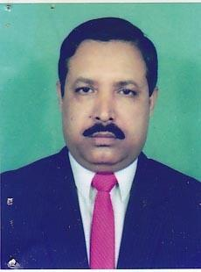 | DR. ABDUR RAZZAQUE  F/Name: Late Monsur Ali  M/Name:  BM & DC Reg. No:  NID:  Cell:  Address: Poonam Nursing Home Medical Road Jamalpur  Blood Group:
3 | Voter No  LM-2300003 | DR. BISWAS CHITTA RANJAN  F/Name: Late Biswas Bijoy Krishna  M/Name:  BM & DC Reg. No:  NID:  Cell:  Address: Consultant, Anaesthesiology General Hospital Jamalpur  Blood Group:
4 | Voter No  LM-2300004  No Image | DR. MD. AMJAD HOSSAIN KHAN  F/Name:  M/Name:  BM & DC Reg. No:  NID:  Cell:  Address:  Blood Group:  TRANSFERED to BMA Dhaka City  LM-1405543
5 | Voter No  LM-2300005  No Image | DR. MD. ANWARUZZAMAN  F/Name:  M/Name:  BM & DC Reg. No:  NID:  Cell:  Address:  Blood Group:  TRANSFERED to BMA Dhaka City  LM-1405543
6 | Voter No  LM-2300006  No Image | DR. MD. ABDUL BASIT  F/Name:  M/Name:  BM & DC Reg. No:  NID:  Cell:  Address:  Blood Group:  TRANSFERED to BMA Dhaka City  LM-1405543
7 | Voter No  LM-2300007  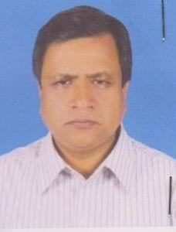 | DR. R A M KAUSARUL ISLAM  F/Name: A K M Nurul Islam  M/Name:  BM & DC Reg. No:  NID:  Cell:  Address: Noyapara Near Golapbagh, Jamalpur.  Blood Group:
8 | Voter No  LM-2300008 | DR.FAKHRIA ALAM  F/Name: Fashihul Alam Mohammad Abdul Rafiq  M/Name:  BM & DC Reg. No:  NID:  Cell:  Address: Noyapara Near Golapbagh Jamalpur.  Blood Group:
9 | Voter No  LM-2300009 | DR. NARAYAN CHANDRA DEY  F/Name: Late Hari Nath Dey  M/Name: Kamala Dey  BM & DC Reg. No: 12365  NID: 9325706158152  Cell: 01712860701  Address: Civil Surgeon, Jamalpur  Blood Group: B+
10 | Voter No  LM-2300010  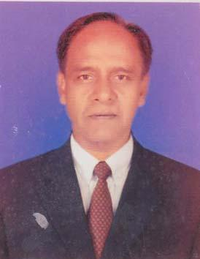 | DR. MD. SHAFI UDDIN  F/Name: Late Elahi Sarker  M/Name: Late- Sukitannessa  BM & DC Reg. No: 9006  NID: 3018531058000  Cell: 01718176840  Address: Vill- Krishnapur, P.O.- Garadoba, Upazila- Sharishabari, Dist.- Jamalpur  Blood Group: B+
11 | Voter No  LM-2300011 | DR. MD. ABDUL AZIZ  F/Name: Alhaj Adam Ali Howladar  M/Name: Late Kulsum Bibi  BM & DC Reg. No: 14500  NID: 2611038776525  Cell: 01716448768  Address: Senior Consultant, Sergery. 250 Bedded General Hospital, Jamalpur  Blood Group:
12 | Voter No  LM-2300012  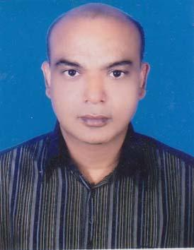 | DR. S.M. SHAMSUZZAMAN  F/Name: Nakib Uddin Ahmed  M/Name: Shamsun Nahar  BM & DC Reg. No: 15070  NID: 19613923606000001  Cell: 01711632283  Address: Upazila Health Complex, Islampur, Jamalpur  Blood Group: B+
13 | Voter No  LM-2300013 | DR. MOHAMMAD TAZUL ISLAM  F/Name: Md. Abdur Razzaque  M/Name: Mst. Tahura Khatun  BM & DC Reg. No: 30935  NID: 3916176545718  Cell: 01717562698  Address: Sampan, (1st Floor), North Kacharipara, Jamalpur  Blood Group: O+
14 | Voter No  LM-2300014 | DR. M. A. MANNAN KHAN  F/Name: Late Abdur Rahman Khan  M/Name: Mrs. Fatima Begum  BM & DC Reg. No: 11909  NID: 19553923603115594  Cell: 01711680462  Address: Jamlpur Medical Hospital Jamalpur  Blood Group: B+
15 | Voter No  LM-2300015 | DR. MUHAMMAD HAFIZUR RAHMAN  F/Name: Late Abdul Awal Miah  M/Name: Halima Khatun  BM & DC Reg. No: 13986  NID: 3923602111717  Cell: 01718512045  Address: Director, Jamalpur Diabetic Hospital, Dist-Jamalpur-2000  Blood Group: B+
16 | Voter No  LM-2300016 | DR. MD. ABDUL WAKIL  F/Name: Md. Abdul Wajed  M/Name: Mrs. Ayesha Khatun  BM & DC Reg. No: 15646  NID: 1022020201370  Cell: 01711141668  Address: Principal Jamalpur Medical College, Jamalpur  Blood Group: B+
17 | Voter No  LM-2300017 | DR. MUSHAIR UL ISLAM  F/Name: Nazrul Islam  M/Name: Late Moslema Islam  BM & DC Reg. No: 14637  NID: 3923604127406  Cell: 01711632276  Address: Civil Surgeon, Civil Surgeon Office, Jamalpur  Blood Group: A+
18 | Voter No  LM-2300018 | DR. ABDULLAH AL AMIN  F/Name: Lutfur Rahman  M/Name: Amina Khatun  BM & DC Reg. No: 14870  NID: 19583923602111899  Cell: 01712095085  Address: Amlapara, Jamalpur  Blood Group:
19 | Voter No  LM-2300019  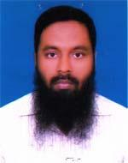 | DR. MAHMUD UL HUDA  F/Name: Shamsul Huda  M/Name: Mursheda Khanum  BM & DC Reg. No: 25642  NID: 2692848056907  Cell: 01714448494  Address: Jamalpur Medical Hospital, Jamalpur  Blood Group: O+
20 | Voter No  LM-2300020 | DR. S. M. MASUD ALAM  F/Name: Nurul Alam  M/Name: Achia Khatun  BM & DC Reg. No: 25858  NID: 9196204138844  Cell: 01712062508  Address: Junior Consultant Pathology, Dept. of Pathology, 250 Bed General Hospital, Jamalpur  Blood Group: AB+
21 | Voter No  LM-2300021 | DR. MD. TAZUL ISLAM  F/Name: Late Mia Hossain  M/Name: Late Meherunnesa  BM & DC Reg. No: 30524  NID: 7625509163744  Cell: 01758820255  Address: 250 Beded General Hospital, Jamalpur  Blood Group: O+
22 | Voter No  LM-2300022  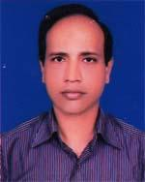 | DR. BIPLOB KUMAR PODDAR  F/Name: Kambu Kantha Poddar  M/Name: Kamala Saha  BM & DC Reg. No: 27989  NID: 6125209168410  Cell: 01716899701  Address: 250 Bedded General Hospital, Jamalpur  Blood Group: AB+
23 | Voter No  LM-2300023  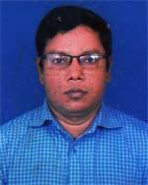 | DR. MD. ABDUL BATEN  F/Name: Md. Abul Kashem  M/Name: Mrs. Sufia Begum  BM & DC Reg. No: 25643  NID: 6125214204866  Cell: 01712102149  Address: Junior Consultant Surgery, 250 Beded General Hospital, Jamalpur  Blood Group: B+
24 | Voter No  LM-2300024 | DR. SAJDA E JANNAT  F/Name: Dr. Sufi Ziaul Hanue  M/Name: Nurunnahar  BM & DC Reg. No: 18059  NID: 3927661420133  Cell: 01715867168  Address: Zia Health Complex Jamalpur.  Blood Group: B+
25 | Voter No  LM-2300025 | DR. MD. FAZLUL HAQUE  F/Name: Md. Alim Uddin  M/Name: Mrs. Abida Begum  BM & DC Reg. No: 30506  NID: 3916176527091  Cell: 01712138396  Address: Sarishabari Health Complex, Sarishabari, Jamalpur  Blood Group: B+
26 | Voter No  LM-2300026 | DR. MD. LUTFUR RAHMAN  F/Name: Asadullah Miah  M/Name: Latifa Khatun  BM & DC Reg. No: 44466  NID: 1322209134861  Cell: 01924271600  Address: Khamarbari, Jamalpur  Blood Group: A+
27 | Voter No  LM-2300027 | DR. ARIFUL ISLAM  F/Name: Nurul Islam  M/Name: Sufia Khatun  BM & DC Reg. No: 58811  NID: 2692619476296  Cell: 01717451735  Address: Officers Quarter, Sarishabari, Upazilla Health Complex  Blood Group: O+
28 | Voter No  LM-2300028 | DR. NOOR E ALAM  F/Name: Md. Jamsher Ali  M/Name: Sajeda Aktar  BM & DC Reg. No: 56777  NID: 0695126298130  Cell: 01712778574  Address: Medical Officer, Satpoa Union Sub Centre, Sarishabari, Jamalpur  Blood Group: O+
29 | Voter No  LM-2300029 | DR.TOUFIQ HASAN KHAN  F/Name: Md. Humayun Khan  M/Name: Shameem Ara Khanam  BM & DC Reg. No: 58176  NID: 2696536935432  Cell: 01710454871  Address: Jamalpur Medical College  Blood Group: O+
30 | Voter No  LM-2300030 | DR. RASHEDA BEGUM  F/Name: Dr. Muhammad Abdus Razzaque  M/Name: Anjumanara Begum  BM & DC Reg. No: 56432  NID: 3923603119598  Cell: 01712204495  Address: Asluka Medical College Road  Blood Group: A+
31 | Voter No  LM-2300031  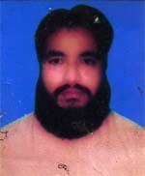 | DR. MUMTAZ UDDIN AHMED  F/Name: Late Mustafizur Rahman  M/Name: Moslema Begum  BM & DC Reg. No: 52410  NID: 8524904043205  Cell: 01712667699  Address: Doctors Quarter, Upazilla Health Complex, Sarishabari, Jamalpur  Blood Group: AB+
32 | Voter No  LM-2300032 | DR. JANNATUL FERDOUS RUPA  F/Name: A. K. M Zakaria Hossain  M/Name: Rowshon Ara Begum  BM & DC Reg. No: 75441  NID: 19898918813000073  Cell: 01789863589  Address: Doctors Quarter, Upazilla Health Complex, Sarishabari, Jamalpur  Blood Group: O+
33 | Voter No  LM-2300033 | DR. MD. ALAUDDIN  F/Name: Late Abdul Awal  M/Name: Fahmida Begum  BM & DC Reg. No: 45374  NID: 2697557397238  Cell: 01816447979  Address: 154/3, Ward-02, Amlapara, Jamalpur  Blood Group: A+
34 | Voter No  LM-2300034 | DR. MOHAMMAD SHAMSUL HAQUE  F/Name: Mohammad Taj Uddin  M/Name: Mrs. Firoza Begum  BM & DC Reg. No: 38352  NID: 3923603117298  Cell: 01711192599  Address: House No. 121, Block 1/3, Road no. 07, Miapara, Jamalpur  Blood Group: A+

